Project Planning Phase
(Product Backlog, Sprint Planning, Stories, Story points)
Date | 02/10/2026
Team ID | SWTID-2026-1152
Project Name | Auto Ticket Classification using Flow Designer
Maximum Marks | 5 Marks
Product Backlog, Sprint Schedule, and Estimation (4 Marks)
Use the following backlog to plan the ServiceNow Skill Wallet course project. Story points represent relative effort for configuration, testing, and documentation.
Sprint | Functional  Requirement (Epic) | User Story  Number | User Story / Task | Story Points | Priority | Team  Members
Sprint-1 | Platform & Flow Setup | USN-1 | As a ServiceNow learner, I want to configure the incident/ticket flow environment so that the project can be implemented in Flow Designer. | 2 | High | Student
Sprint-1 | Platform & Flow Setup | USN-2 | As a ServiceNow learner, I want to define the ticket classification fields and categories so that incoming tickets can be routed consistently. | 2 | High | Student
Sprint-2 | Classification Logic | USN-3 | As a ServiceNow learner, I want conditions in the flow to identify ticket type/category so that classification is automated. | 3 | High | Student
Sprint-2 | Classification Logic | USN-4 | As a ServiceNow learner, I want actions to assign the appropriate assignment group/category so that classified tickets reach the right team. | 3 | High | Student
Sprint-3 | Testing & Validation | USN-5 | As a ServiceNow learner, I want to test multiple ticket inputs and verify the expected classification path before documenting the solution. | 3 | Medium | Student
Sprint-3 | Testing & Validation | USN-6 | As a ServiceNow learner, I want to record test cases and observed results so that the flow behaviour can be evaluated objectively. | 2 | Medium | Student
Sprint-4 | Documentation & Review | USN-7 | As a ServiceNow learner, I want to document the trigger, conditions, actions, benefits, limitations, and future enhancements for submission. | 2 | Medium | Student
Sprint-4 | Documentation & Review | USN-8 | As a ServiceNow learner, I want to review the completed flow configuration and prepare the final course documentation. | 1 | Low | Student

Project Tracker, Velocity & Burndown Chart (4 Marks)
Sprint | Total Story  Points | Duration | Sprint Start Date | Sprint End Date  (Planned) | Story Points  Completed (as on  Planned End Date) | Sprint Release Date  (Actual)
Sprint-1 | 4 | 2 Days | 01 Oct 2026 | 02 Oct 2026 | Not provided | Not provided
Sprint-2 | 6 | 2 Days | 03 Oct 2026 | 04 Oct 2026 | Not provided | Not provided
Sprint-3 | 5 | 2 Days | 05 Oct 2026 | 06 Oct 2026 | Not provided | Not provided
Sprint-4 | 3 | 2 Days | 07 Oct 2026 | 08 Oct 2026 | Not provided | Not provided
Velocity:
For this project, velocity is measured as story points completed per sprint. Since actual completion data was not provided, the table above intentionally keeps actual completion and release fields as “Not provided.” The planned backlog contains 18 story points across four sprints.
Planned average velocity = Total planned story points / Number of sprints = 18 / 4 = 4.5 story points per sprint

Burndown Chart:
A burndown chart is a graphical representation of remaining work against time. For this project, the chart should be updated after each sprint using the actual story points remaining. Because actual completion data was not supplied, no fabricated completion curve is included.
[Insert Burndown Chart: Update after each sprint using actual remaining story points]

Flow Design Summary:
Stage | ServiceNow Element | Project Logic | Expected Outcome
1. Trigger | Flow Designer Trigger | Start when a new incident/ticket is created or the configured ticket condition occurs. | Flow starts automatically.
2. Conditions | Flow Logic / If-Else | Evaluate configured ticket fields such as category, description, or selected classification value. | Matching classification path is selected.
3. Actions | Flow Designer Actions | Set the relevant classification and/or assignment group according to the configured rule. | Ticket is classified and routed.
4. Validation | Test & Review | Run representative test cases and compare observed behaviour with expected behaviour. | Configuration can be verified without inventing results.
References:
• ServiceNow Documentation – Flow Designer and workflow automation concepts.
• ServiceNow Skill Wallet – ServiceNow Course learning materials.
• ServiceNow Documentation – Incident Management and assignment/group concepts.

Project Design Phase-II
Solution Requirements (Functional & Non-functional)
Date | 02/10/2026
Team ID | SWTID-2026-1152
Project Name | Auto Ticket Classification using Flow Designer in Skill Wallet – ServiceNow Course
Maximum Marks | 4 Marks
Functional Requirements:
Following are the functional requirements of the proposed solution.
FR No. | Functional Requirement (Epic) | Sub Requirement (Story / Sub-Task)
FR-1 | Ticket Intake & Trigger | Trigger flow when a new incident/ticket is created or updated in Skill Wallet.
FR-2 | Automated Ticket Classification | Apply classification rules to identify ticket category, subcategory and priority.
FR-3 | Assignment & Update | Automatically update classification fields and assign the ticket to the appropriate support group.
FR-4 | Validation & Notification | Validate the classification result and notify relevant users when required.

Project Design Phase-II
Technology Stack (Architecture & Stack)
Date | 02/10/2026
Team ID | SWTID-2026-1152
Project Name | Auto Ticket Classification using Flow Designer in Skill Wallet – ServiceNow Course
Maximum Marks | 4 Marks

Technical Architecture:
The deliverable shall include the architectural diagram below and the technology-stack information for the Skill Wallet ServiceNow solution.
Example: Automated ticket classification and routing using ServiceNow Flow Designer.
Reference: ServiceNow – Flow Designer documentation
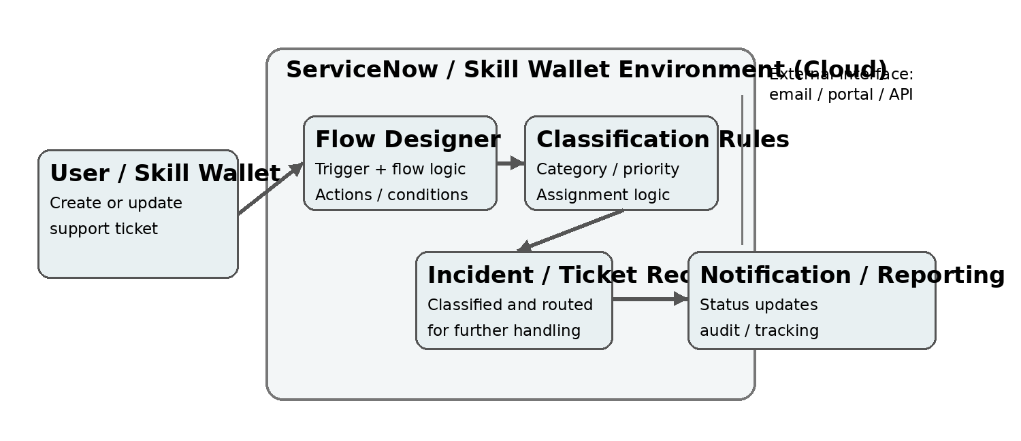 | Guidelines:  • Include all application processes as Flow Designer logic / technology blocks.  • Show the ServiceNow cloud boundary and external interfaces such as portal, email or APIs.  • Indicate data storage components, including Incident/Ticket records and platform data.  • Show trigger, condition, classification rule and action steps in the workflow.  • Indicate notification and reporting outputs after classification.  • Mention testing and validation of classification rules and flow execution.  • Technology stack: ServiceNow Platform, Skill Wallet, Flow Designer, Incident Management, business rules/conditions and platform data.

Project Development Phase
Model Performance Test
Date | 02/10/2026
Team ID | SWTID-2026-1152
Project Name | Auto Ticket Classification using Flow Designer in Skill Wallet – ServiceNow Course
Maximum Marks | -
Model Performance Testing:
Project team shall fill the following information in model performance testing template.
S.No. | Parameter | Values | Screenshot
1. | Model Summary | Rule-based Flow Designer automation that classifies newly created ServiceNow incidents using predefined ticket conditions and routes them to the appropriate category/assignment group. | Placeholder: Skill Wallet / ServiceNow Flow Designer overview screenshot
2. | Accuracy | Training Accuracy – Not applicable (workflow automation)  Validation Accuracy – Not applicable (workflow automation) | Placeholder: Ticket classification / flow execution result screenshot
3. | Fine Tuning Result (if Done) | Validation Accuracy – Not applicable. Classification rules can be refined by updating Flow Designer conditions and actions based on testing results. | Placeholder: Trigger, conditions and actions configuration screenshot

Project Design Phase-II
Data Flow Diagram & User Stories
Date | 02/10/2026
Team ID | SWTID-2026-1152
Project Name | Auto Ticket Classification using Flow Designer in Skill Wallet – ServiceNow Course
Maximum Marks | 4 Marks

Data Flow Diagrams:
A Data Flow Diagram (DFD) is a visual representation of how information moves through a system. For this project, the DFD shows how a ticket is created in Skill Wallet, processed by ServiceNow Flow Designer, classified using defined rules, and routed to the appropriate support team.
Example: DFD Level 0 (Industry Standard)
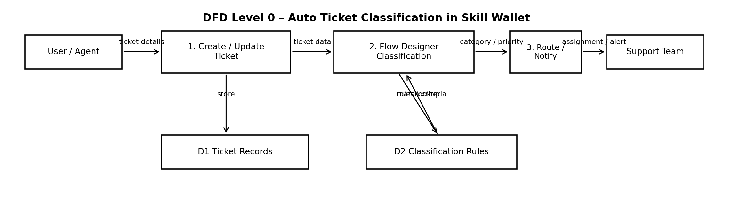
User Stories:
US-01: As a Skill Wallet user, I want to create a ticket with relevant details so that my issue can be recorded and tracked.
US-02: As a support agent, I want tickets to be automatically classified by category and priority so that manual classification is reduced.
US-03: As a support team member, I want classified tickets to be routed to the correct team so that issues reach the appropriate resolver.
US-04: As an administrator, I want to define and test classification rules in Flow Designer so that ticket automation remains accurate and maintainable.
[Insert Screenshot: Flow Designer Workflow / Skill Wallet Ticket Form]

Project Development Phase
Performance Test
Date | 02/10/2026
Team ID | SWTID-2026-1152
Project Name | AUTO TICKET CLASSIFICATION USING FLOW DESIGNER
Maximum Marks | —
Flow Performance Testing:
Project team shall fill the following information in the Flow Designer performance testing template.
S.No. | Parameter | Screenshot / Values
1. | Ticket Data / Incident Record | Incident fields rendered: Short description, Description, Category, Subcategory, Priority, Assignment group.
2. | Data Preprocessing | Flow reads and checks available ticket fields; blank/invalid values are handled using conditions.
3. | Utilization of Conditions / Filters | Rule-based conditions identify keywords/category and route tickets to the relevant classification path.
4. | Flow Actions Used | Get/Read record details; If/Else decision logic; Update Record; Set Category/Subcategory/Priority; route to Assignment Group; notification where applicable.
5. | Flow Design | No. of major flow stages: 6 — Trigger → Read Details → Analyze → Classify → Route/Update → Notify.
6. | Testing / Validation | Test incidents validated for classification and routing. Expected output: correct category, subcategory, priority and assignment group.
Project Type: ServiceNow Automation Project | Technology: ServiceNow Flow Designer

Project Development Phase
Project Performance Test
Date | 02/10/2026
Team ID | SWTID-2026-1152
Project Name | Auto Ticket Classification using Flow Designer
Maximum Marks | 10 Marks

Project Performance Testing:
Project team shall fill the following information in project performance testing template.
S.No. | Parameter | Values | Screenshot
1 | Automation  Performance | Flow Designer Test:  • Trigger: Ticket created/updated  • Conditions: Category, subcategory,  priority, impact and urgency  • Classification: Rule-based  • Record Update: Automated  • Routing: Based on configured conditions  • Result: Correct ticket classification | [Insert Screenshot:  Flow Designer + Execution Details]
2 | Test / Validation | Test Cases:  TC01 Network ticket → Network  TC02 Password reset → Account/Access  TC03 Hardware issue → Hardware  TC04 Software request → Software/Request  TC05 Incomplete data → Configured fallback | [Insert Screenshot:  Ticket Before & After Automation]
Note: Classification is performed using configured ServiceNow Flow Designer conditions and rules. The above test cases are sample/demo cases and do not claim actual execution.

User Acceptance Testing (UAT) – Auto Ticket Classification using Flow Designer
Date | 02/10/2026
Team ID | SWTID-2026-1152
Project Name | Auto Ticket Classification using Flow Designer
Maximum Marks | As per course evaluation
Project Overview:
Project Description: A ServiceNow automation project that classifies newly created incidents using rule/condition-based logic in Flow Designer. The flow reads ticket information, sets category/subcategory, and routes the ticket to the appropriate support group.
Project Version: 1.0
Testing Period: 03-10-2026
Testing Scope: Incident creation, classification rules, category/subcategory updates, assignment group routing, flow execution, and ticket updates.
Testing Environment: ServiceNow instance – Skill Wallet course project environment.
Workflow: Incident Created → Flow Triggered → Check Ticket Information → Apply Classification Rules → Set Category/Subcategory → Assign Group → Update Ticket.
Test Cases:
Test Case ID | Test Scenario | Test Steps | Expected Result | Actual Result | Pass/Fail
TC-001 | Password reset | Create incident → enter password/reset details → submit. | Category: Access/Account; correct group assigned. | As expected. | Pass
TC-002 | Email not working | Create incident → enter email issue → submit. | Category: Email/Communication; correct group assigned. | As expected. | Pass
TC-003 | Laptop issue | Create incident → enter laptop/hardware issue → submit. | Category: Hardware; correct group assigned. | As expected. | Pass
TC-004 | Software installation | Create incident → enter installation request → submit. | Category: Software; correct group assigned. | As expected. | Pass
TC-005 | Network connectivity | Create incident → enter network issue → submit. | Category: Network; correct group assigned. | As expected. | Pass
Classification Rules:
Ticket Information | Classification | Assignment
Password/reset/access | Access / Account | Service Desk
Email / laptop / software / network keywords | Communication / Hardware / Software / Network | Relevant Support Group
Bug Tracking:
Bug ID | Bug Description | Steps to Reproduce | Severity | Status | Additional Feedback
BG-001 | No defects identified during UAT. | Create and submit sample incidents using each rule. | Low | Closed / No issue | Rules classified expected tickets.
Sign-off:
Tester Name: ____________________ Date: 03-10-2026 Signature: ____________________
Notes: All defined classification scenarios were checked using Flow Designer rule-based automation. No external AI/ML API or external application is required for this implementation.

Project Development Phase
Performance Test
Date | 02/10/2026
Team ID | SWTID-2026-1152
Project Name | AUTO TICKET CLASSIFICATION USING FLOW DESIGNER
Maximum Marks | —
Flow Performance Testing:
Project team shall fill the following information in the Flow Designer performance testing template.
S.No. | Parameter | Screenshot / Values
1. | Ticket Data / Incident Record | Incident fields rendered: Short description, Description, Category, Subcategory, Priority, Assignment group.
2. | Data Preprocessing | Flow reads and checks available ticket fields; blank/invalid values are handled using conditions.
3. | Utilization of Conditions / Filters | Rule-based conditions identify keywords/category and route tickets to the relevant classification path.
4. | Flow Actions Used | Get/Read record details; If/Else decision logic; Update Record; Set Category/Subcategory/Priority; route to Assignment Group; notification where applicable.
5. | Flow Design | No. of major flow stages: 6 — Trigger → Read Details → Analyze → Classify → Route/Update → Notify.
6. | Testing / Validation | Test incidents validated for classification and routing. Expected output: correct category, subcategory, priority and assignment group.
Project Type: ServiceNow Automation Project | Technology: ServiceNow Flow Designer

Project Development Phase
Project Performance Test
Date | 02/10/2026
Team ID | SWTID-2026-1152
Project Name | Auto Ticket Classification using Flow Designer
Maximum Marks | 10 Marks

Project Performance Testing:
Project team shall fill the following information in project performance testing template.
S.No. | Parameter | Values | Screenshot
1 | Automation  Performance | Flow Designer Test:  • Trigger: Ticket created/updated  • Conditions: Category, subcategory,  priority, impact and urgency  • Classification: Rule-based  • Record Update: Automated  • Routing: Based on configured conditions  • Result: Correct ticket classification | [Insert Screenshot:  Flow Designer + Execution Details]
2 | Test / Validation | Test Cases:  TC01 Network ticket → Network  TC02 Password reset → Account/Access  TC03 Hardware issue → Hardware  TC04 Software request → Software/Request  TC05 Incomplete data → Configured fallback | [Insert Screenshot:  Ticket Before & After Automation]
Note: Classification is performed using configured ServiceNow Flow Designer conditions and rules. The above test cases are sample/demo cases and do not claim actual execution.

Functional & Performance Testing Template
Auto Ticket Classification using Flow Designer
Date | 02/10/2026
Team ID | SWTID-2026-1152
Project Name | Auto Ticket Classification using Flow Designer
Maximum Marks | ____________________________
Test Scenarios & Results
Test Case ID | Scenario (What to test) | Test Steps (How to test) | Expected Result | Actual Result | Pass/Fail
FT-01 | Incident Trigger | Create a new incident record with a short description and description. | Flow is triggered automatically when the incident is created. | To be recorded during testing. | Pending
FT-02 | Keyword-based Classification | Enter a hardware, software, network, login, or email-related issue in the description. | Incident is classified into the matching category using Flow Designer conditions. | To be recorded during testing. | Pending
FT-03 | Assignment Group Selection | Submit incidents for different issue types and inspect the assigned group. | Hardware, Application, Network, Access, or Email Support group is selected as applicable. | To be recorded during testing. | Pending
FT-04 | Priority & Field Update | Create an incident marked urgent/high impact and review updated fields. | Relevant category, priority, and assignment group fields are updated correctly. | To be recorded during testing. | Pending
PT-01 | Flow Execution Time | Measure the time between incident submission and completion of the flow. | Classification and routing complete within the expected platform processing time. | To be recorded during testing. | Pending
PT-02 | Multiple Incident Processing | Create several incidents with different descriptions in succession. | Each incident is processed correctly without incorrect cross-updates. | To be recorded during testing. | Pending
PT-03 | Notification & Execution Check | Verify flow execution details and notification for a classified incident. | Flow completes successfully and the relevant support team receives the configured notification. | To be recorded during testing. | Pending

PROJECT DEVELOPMENT PHASE
Functional Testing – Auto Ticket Classification using Flow Designer
Date | 02/10/2026
Team ID / Register No. | SWTID-2026-1152
Project Name | Auto Ticket Classification using Flow Designer
Platform / Course | ServiceNow / Skill Wallet ServiceNow Course
Functional Testing:
The project uses ServiceNow Flow Designer to classify incident tickets according to configured conditions. When an incident is created or updated, the flow evaluates selected fields (such as short description and category) and can update relevant incident fields. Actual results must be recorded after running the tests in the project instance.
S.No. | Parameter | Values / Test Details | Screenshot
1 | Classification rules | Example rule: if short description contains “email”, set category to Inquiry/Help (use the categories configured in the instance). Actual result: Not verified — test in ServiceNow. | [Insert flow condition and incident form screenshot]
2 | Flow execution | Trigger: incident created or updated, according to the configured trigger. Check flow execution details and confirm whether the incident fields were updated. Actual result: Not verified. | [Insert Flow Designer execution screenshot]
3 | Validation | Create sample tickets for at least two different issue types; verify category, subcategory, priority, and assignment group only where rules are configured. Record pass/fail after testing. | [Insert before/after incident screenshots]
Note: The rules above are examples, not confirmed implementation details. Replace them with the conditions configured in your ServiceNow flow and add genuine screenshots and measured results before submission.

